Brickyard Broadcast – CSC Singer checklist

YOUR PARTS ARE ON THE CSC MEMBER PAGE.

THIS PROJECT WEBSITE IS WHERE YOU WILL FIND RESOURCES AND WHERE YOU WILL UPLOAD YOUR FINISHED RECORDINGS:
https://go.ncsu.edu/brickyardbroadcast

MUSICAL INSTRUCTIONS FOR READING PARTS:
- Double bars = divisions between separate sound objects, LEAVE SPACE!
- Repeat as desired = sing however many of them you like!
- Phrases in boxes = repeat the phrase for the given duration, pausing in between
- Phrases with brackets = sing phrases ONCE in order, pausing in between
- Timings (c.20”, etc.) = loosely defined, can be approximate
- Notes with no stems = sing them at any tempo, explore different tempos
- Repeats inside boxes = sing multiple times with no break, then pause and do it again, etc.
- HAVE FUN! These parts are designed to give you maximum freedom to play your instruments and sing, without having to align with click tracks or synchronize with one another. Explore – show me something unexpected!

PRACTICING AND PREPARING:
- If you find something difficult or awkward, you may CHANGE IT or LEAVE IT OUT!
- If you have questions, you can email me anytime! lcbielaw@ncsu.edu

RECORDING:
- Please listen to the TUNING TRACK that will be uploaded to the same Google folder where you found your parts, just before you record. Use the TUNING TRACK to get the pitch and tonal center in your mind and ear. The tuning track IS NOT your part exactly. Some may be the same, but do not substitute the notes in the tuning track for the notes in your part.
- When you are ready to record, DO NOT LISTEN to other tracks. Simply sing as you wish to sing.
- To set up your microphone and recording environment, please follow the tips in the instructional video at the informational Brickyard Broadcast site.
- Record each lettered section as its own file, pausing at the double bars as needed.
- Within each lettered section, you may give yourself pitches between phrases as you need. However, if you do, you MUST let the sound reverb end completely before you start singing, so that the pitches you gave yourself are not heard along with your singing.
- INCLUDE ONLY ONE PASS of the materials as they are laid out in your part. Do not upload multiple takes of the same material unless the part itself instructs you to sing something multiple times.
- For section L: GROOVE TRACKS have been uploaded to the member page so you can sing along with whatever speed groove you like. If you do not wish to sing while listening, you may listen to a groove track, then record “wild,” (without the groove track), keeping the tempo in your mind while you sing.

TOOLS AND AIDS
- There are many free phone apps available for metronome (to give you tempo) for pitch pipe (to give you pitches) or keyboard/piano (to give pitches and play lines)
- There are also several web applications you can access on your computer while using your phone to record:
  - virtualpiano.net (keyboard with metronome)
  - google metronome (just google “metronome”)
  - https://pitchpipe.app/#/ (for pitches)
- Here is an image translating staff notes to the keyboard:
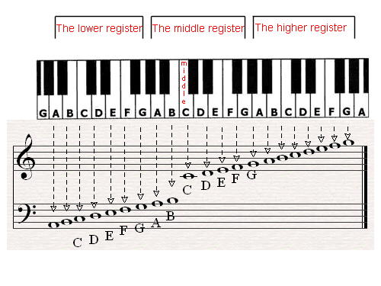

DEADLINES ARE AT 5pm ON THESE DATES:
- Concert Singers of Cary: Sunday, October 11

