MUSIC OF HOPE AND LOVE
Featuring works by Jake Runestad

The Concert Singers of Cary Symphonic Choir
Allen Bailey, pianist; Nathan Leaf, conductor
with
Mallarmé Chamber Players
Lucy Greenleaf and Anne Leyland, violin;
Jacobus Hermsen, viola; Nathan Leyland, cello
and
The Panther Creek High School Chamber Choir
Brad Bensen, director

Program notes:
In the first half of this evening’s concert, we consider challenges in our society that are prevalent but not easy to discuss. The first work, A Silence Haunts Me, is a dramatic musical adaptation of Beethoven’s Heiligenstadt Testament, with a libretto by poet Todd Boss, set to music by Jake Runestad. The “testament” is a letter written in October 1802 by Beethoven, addressed to his brothers but never sent. He was then in his early 30s and established in Vienna as a composer, though not yet as one of the greats. He had been dealing with hearing problems for several years, and earlier that year it became clear that his hearing would not improve and that he would most likely go completely deaf. He retreated to the country village of Heiligenstadt for several months trying to come to terms with his condition and what it would mean for his life and work, and where he penned the letter. In it, he discusses his despair over losing “the one sense that should have been more perfect in me than in others,” describes anxiety and loneliness over being forced to hide his situation and withdraw from society, and confesses that, being pushed to the limits of his capacity to manage, “but little more and I would have put an end to my life.” His letter also provides a ray of hope, as he vows to live on, despite his disability, to try to fulfill his artistic destiny. 1802 was a turning point in Beethoven’s life and career. It was the beginning of his second, heroic, period, ushered in by, among other works, his Third Symphony, which premiered in 1805.
The second work in our concert is a plea for suicide prevention and awareness. We are joined by students from Cary’s Panther Creek High School. For the text of Please Stay, Runestad compiled statements from tweets using “#IKeptLiving—expressions of hope from those who battle depression and chose to live.” He weaves the words into a tapestry of support and encouragement to show to any person who may feel, as Beethoven did, that they can only take “but little more,” that they are not alone and that “you are life, beauty, light; your story is not over.” The words and the music are simple and direct, which is perhaps best for such a profound and challenging topic.
We then present four selections by Beethoven, most of which we have only because he decided to stay with us. The pieces are all very different, and from different times in his life. They reflect a spirit of thankfulness, joy, and love, all of which we can more deeply appreciate knowing that he had overcome deep personal struggles to write them. String Quartet Number 15 was written in 1825, near the end of his life, following his recovery from a very serious illness. His inscription at the beginning of the third movement reads, “Holy song of thanksgiving of a convalescent to the Deity, in the Lydian mode.” We share a brief section of his revolutionary Ninth Symphony, with its setting of the key words Freunde (friends) and Freude (joy) seeming appropriate here. His song Ich liebe dich (I love you), one of the great melodies of its time, tells of the importance of the human connection. We conclude the first half with the triumphant closing Hallelujah from his oratorio, Christ on the Mount of Olives. This is a beloved chestnut for choirs everywhere, a fitting conclusion to the first half of the concert, as it was written in late 1802, just after Beethoven wrote his letter in Heiligenstadt.
The second half begins with the Chamber Choir of Panther Creek High School, under the direction of Brad Bensen. These singers are a credit to our community, and we are pleased to have them with us as our guests tonight. Concert Singers are then joined by musicians from Mallarmé Chamber Players for a performance of the six-movement work for choir and string quartet, The Hope of Loving. Runestad compiles texts from various authors into a lush and inviting composition examining the role of hope and love in our lives.
Award-winning composer Jake Runestad (b. 1986) has emerged as one of choral music’s newest leading voices. With commissions and performances from leading musical organizations, he is one of the most frequently performed composers in the country. Dubbed a “choral rock star” by American Public Media, he has traveled worldwide to work with ensembles performing his music. He holds a Master’s degree in composition from the Peabody Conservatory, and lives in Minneapolis.

Texts and Translations:
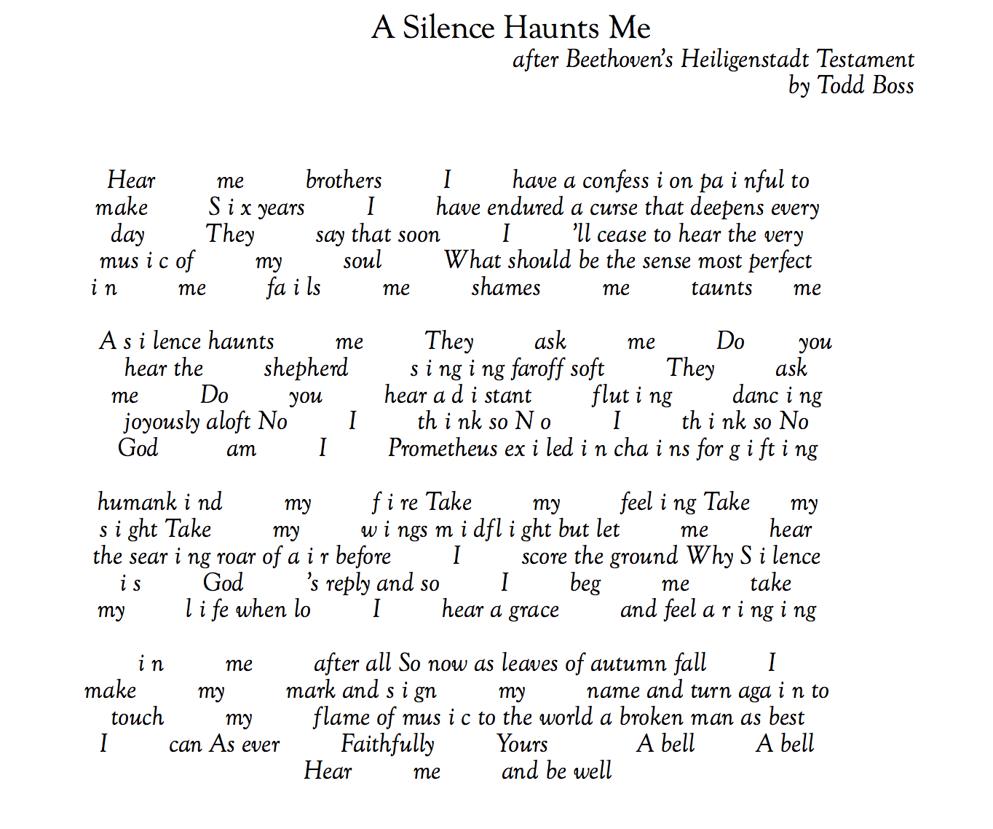

Please Stay

No! Don’t go! You are breath, you are life,
Don’t let your worst day be your last. you are beauty, you are light.
The storm is strong, but it will pass. Your story is not over.
You think you can’t go on another day, You are not a burden to anyone.
but please stay. Just stay. Please stay. Just stay.
Hope is real. Help is real.

tweets compiled by the composer from: #IKeptLiving—expressions
of hope from those who battle depression and chose to live.
Excerpt from the Ninth Symphony
Text by Friedrich Schiller (1759-1805)

O Freunde, nicht diese Töne!
Sondern laßt uns angenehmere anstimmen,
und freudenvollere.

Freude, schöner Götterfunken,
Tochter aus Elysium!
wir betreten feuertrunken,
himmlische, Dein Heiligtum.
Deine Zauber binden wieder,
was die Mode streng geteilt,
alle Menschen werden Brüder,
wo Dein sanfter Flügel weilt.
Oh friends, not these sounds!
Let us instead strike up more pleasing
and more joyful ones!

Joy, beautiful sparkle of divinity,
daughter from Elysium,
we enter, burning with fervour,
heavenly being, your sanctuary!
Your magic brings together
what custom has sternly divided.
All men shall become brothers,
wherever your gentle wings hover.

Ich liebe dich
Text by Karl Friedrich Wilhelm Herrosee (1764-1821)

Ich liebe dich, so wie du mich,
Am Abend und am Morgen,
Noch war kein Tag, wo du und ich
Nicht teilten unsre Sorgen.

Auch waren sie für dich und mich
Geteilt leicht zu ertragen;
Du tröstetest im Kummer mich,
Ich weint in deine Klagen.

Drum Gottes Segen über dir,
Du, meines Lebens Freude.
Gott schütze dich, erhalt dich mir,
Schütz und erhalt uns beide.

I love you as you love me,
In the evening and in the morning,
Nor was there a day when you and I
Did not share our sorrows.

And when we shared them
They became easier to bear;
You comforted me in my distress,
And I wept in your laments.

May God's blessing be upon you,
You, the joy of my life.
God protect you, keep you for me,
And protect and keep us both.

Hallelujah
(Original German libretto by Franz Xaver Huber, English translation is public domain.)

Hallelujah unto God's Almighty Son.
Praise the Lord, ye bright angelic choirs
In holy songs of Joy.
Man, proclaim his grace and glory,
Hallelujah unto God's Almighty Son
Praise the Lord in holy songs of joy.

The Hope of Loving
(Text adapted from Love Poems from God: Twelve Sacred Voices from the East and West by Daniel Ladinsky.)

I. Yield to Love (Rabia)
I know about love the way the fields know about light,
the way the forest shelters us.
We are vulnerable like an infant.
We need each other’s care or we will suffer.
How will you ever find peace unless you yield to love?
II. Wild Forces (St. Francis of Assisi)
There are beautiful, wild forces within us.
Let them turn millstones inside
filling bushels that reach to the sky.
III. Wondrous Creatures (Hafiz)
O wondrous creatures, by what strange miracle do you so often not smile?
IV. The Heart’s Veil (string quartet)
V. My Soul Is a Candle (St. John of the Cross)
My soul is a candle that burned away the veil;
only the glorious duties of light I now have.
The soul is a candle that will burn away the darkness;
only the glorious duties of love we will have.
Tenderly, I now touch all things, knowing one day we will part.
VI. The Hope of Loving (Meister Eckhart)
What keeps us alive, what allows us to endure?
It is the hope of loving, of being loved.
We weep when light does not reach our hearts.
We wither like fields if someone close
does not rain their kindness upon us.
My soul has a purpose, it is to love.

