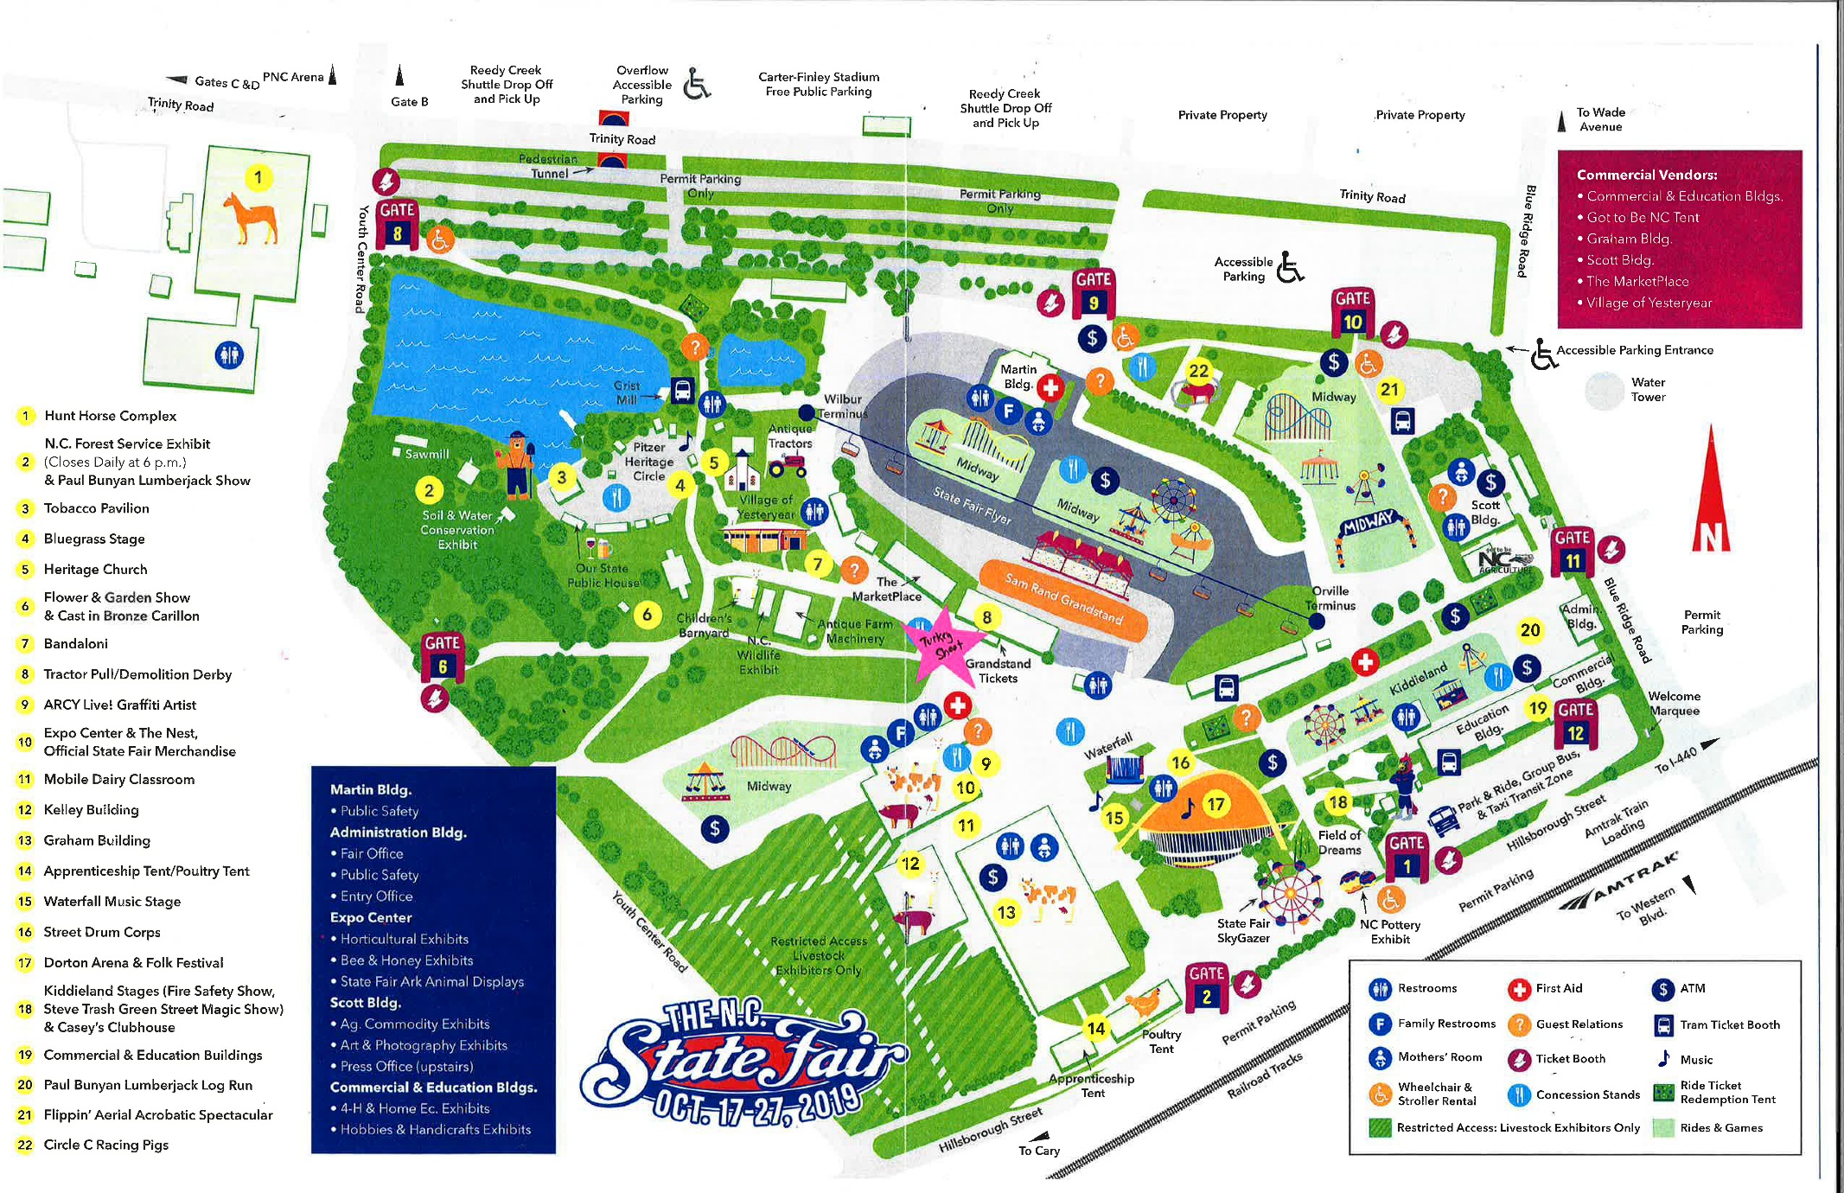
Turkey Shoot Info

Attire
Please wear comfortable clothing that you can be active in and closed-toed shoes.

Parking
Unfortunately, there is no special parking for State Fair volunteers. The lots at the PNC Arena/Football Stadium are near Gate 8, as is the shuttle drop-off point from the remote (Reedy Creek) parking lot.

Getting to the Turkey Shoot Booth
The map on the back side has the location of the Turkey Shoot as a pink star. The shoot is located directly between the Exposition Center and the Grandstand. It has a large fence around the exterior of a white tent and a banner that says Turkey Shoot. The three closest gates are Gate 8 (where you will likely end up if you park at the PNC Arena/Football Stadium), Gate 6, and Gate 2.
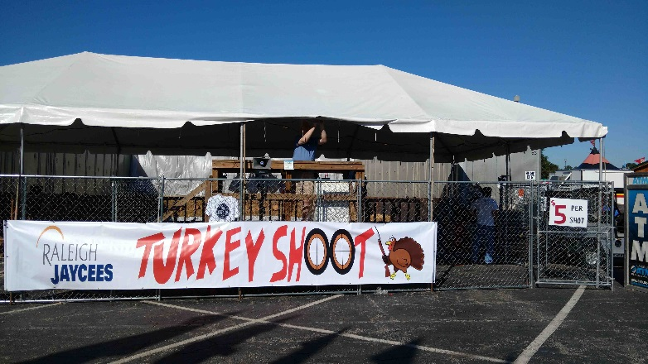

If you have problems…
You will receive an email a day or two before your shift with the cell phone number of your shift captain. If you have a problem, please call them first. If you have trouble reaching them, you can call Rachael’s cell at 812-360-8587.

