Holiday Pops with NC Symphony - 2011

DATE and TIMES
Friday 11/25 Rehearsal Call 9:30AM 10:00 AM – 12:30 PM
Friday 11/25 Concert 1 Call 7:00 PM Perf. 8:00 PM
Saturday 11/26 Concert 2 Call 2:00 PM Perf. 3:00 PM
Saturday 11/26 Concert 3 Call 7:00 PM Perf. 8:00 PM

WHERE:
- Meymandi Hall is part of the Progress Energy Performing Arts Center located at 2 East South Street, Raleigh NC 27601.
- Meet in Meymandi Concert Hall for the Friday morning rehearsal at 9:30AM and then in The Carolina Room prior to concerts. To get to the Carolina Room, enter through the covered picnic area in the rear of the facility adjacent to the Kennedy Theater. You will be directed from there to the Carolina Room.

Location Map in downtown Raleigh
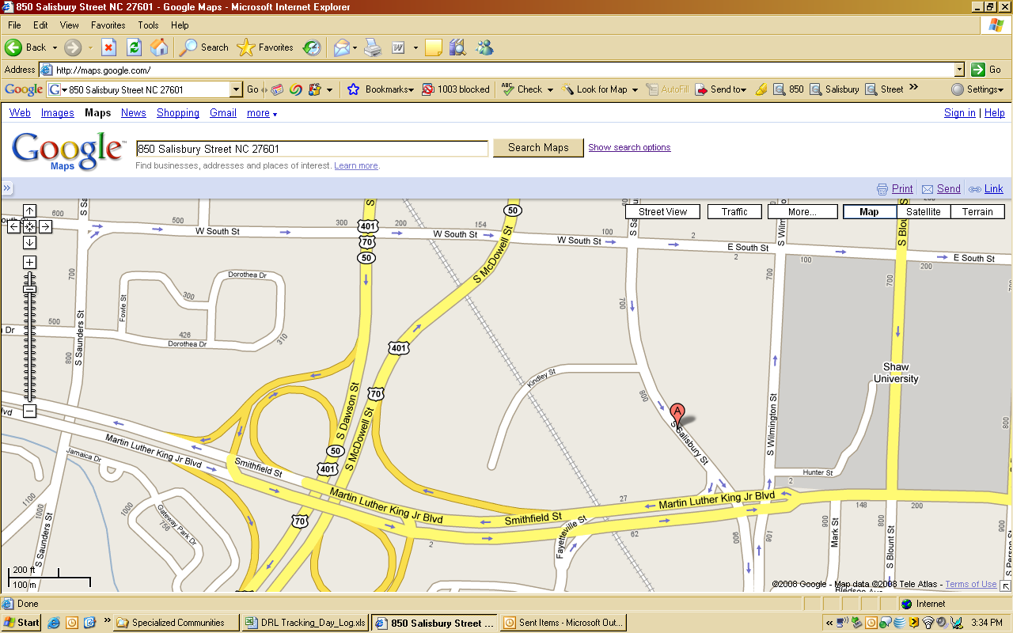
Progress Energy Center

- Allow enough travel time to reach the site, find parking, and walk to the building.

