Tribute to MLK with the Durham Symphony

WHEN:
Rehearsal Friday 1/14 6:45 PM
Concert Saturday 1/15 Call, 6:00 PM

WHERE:
- Friday’s rehearsal and Saturday’s performance will be held at Durham Armory. The Armory is located at 220 Foster Street, Durham, NC, 27710.
- Parking is available at the deck on the corner of Foster and W. Morgan. A small fee will be charged to park in this area. This is the recommended parking for all singers and symphony members. Do not park in lots that are reserved for the Marriott, you may be towed. Please carpool if possible.

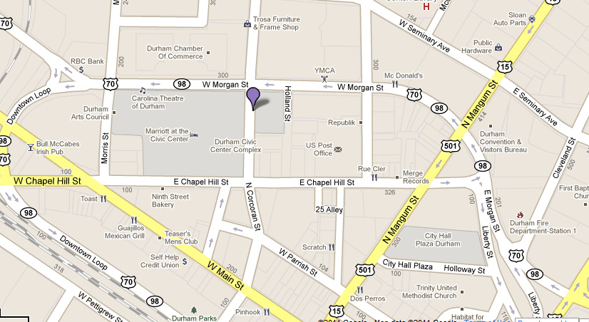
Armory
Pay
Parking

- Do not ask questions during the rehearsal. Ask Larry afterwards during our debriefing. Please keep talking during rehearsal to a minimum.
- Please be on time. Allow enough time to reach the site, find parking, and walk to the building.
- Water bottles are okay to bring on stage. No other food or drink items are permitted.
- Dress comfortably for the rehearsal.
- Concert attire is Informal Black. Details on attire can be found in the members section of the website under Guidelines and Ground Rules.
- Any other questions? Contact, Amanda at 919-602-9966 or your section leader. Don’t wait until the last minute!

